LYNX

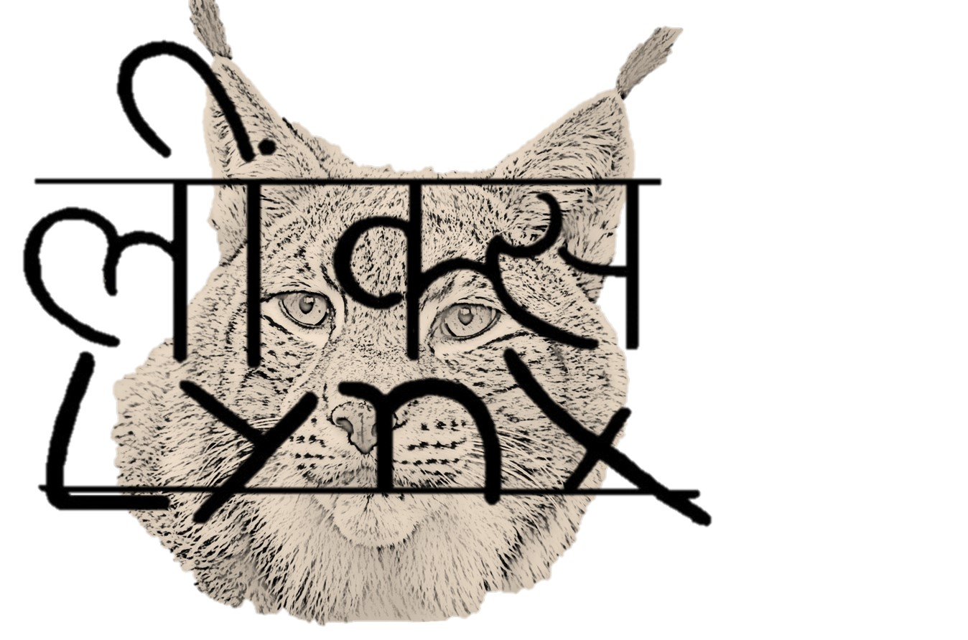

A website narrative on my experiences having an e-book
of poetry published and distributed to children in Nepal.
March 2015 – April 2016
Ann M. Mayer
An Unexpected Road to Nepal

Part One

How It Came About

Just as the course your life takes depends on chance encounters, so did the evolution of this small book of poems. Not all encounters can be expected to lead to a favorable outcome. Some may lead nowhere, some may lead to an insurmountable wall, but others may open new vistas.

This is a narrative about the complex web of people and events (links) which led to the production of my first book of poems, Endangered Animals of Nepal - Poems.
(http://www.a-teamforwildlife.org/e-book)

Scattered about in my narrative are links to other websites, which contain maps and photographs related to the subject matter.

I have also included sources of information about some of the many endangered animals (such as the lynx), which people are coming to realize will likely disappear forever if no one looks at the links between all living creatures.

******************************

Some people have asked how I got interested in Nepal. Completely by chance. When I was transferred from independent living to assisted living at the retirement community where I live, one of the CNAs who took care of me was Jagadish, a man in his late sixties, originally from Nepal. He was especially helpful to me because he was closer to my age than any of the other CNAs. He had an entirely different perspective on how to help me based on years of life experiences that younger people often do not have. His blend of eastern and western philosophy and medicine plus talk therapy reawakened my interest in other nations and cultures as well as my life-long interest in the animal world.

As we were talking, I found out he had majored in zoology (as I did) at Tribuhaven University in Nepal. ( http://tribhuvan-university.edu.np/. ) I asked him about his experiences in college in Kirtipur, Kathmandu. He told me in great detail about a field study of the gharial in which he participated one summer at Royal Chitwan National Park in Nepal. (http://www.chitwannationalpark.gov.np )

The participants, mainly young college students, lived outdoors. When monsoon season arrived, there were pests such as leeches and clouds of mosquitos, made even
more annoying by the 100+ degree heat and suffocating humidity. There was constant danger of encountering poisonous and non-poisonous snakes, tigers, leopards, elephants, rhinos. The study participants often had to sleep on the beach all night with an ear to the ground listening for the first sounds of the gharial eggs hatching.

Having never heard of a gharial, I did some research to find out more about it with the thought that I might write a piece aimed at an American audience. However, there was a scarcity of reliable, first-hand material which would be interesting enough to include in an article. Then the thought occurred to me that there were probably many other unusual animals living in Nepal which I knew nothing about. My research turned up one of the oddest looking creatures I had ever seen!

The pangolin looked like a huge pine cone with fat legs and a pointed proboscis.
Further research turned up the fact that there were eight species of pangolins, four Asian and four African, and all were seriously endangered. The numerous features of this creature lent themselves to a silly poem more than a serious article. I have always enjoyed writing poetry, especially silly poems, so I decided to try using this format to describe the pangolin.

My endeavor led to a four-stanza poem incorporating some of the biology and ecology of the pangolin (Manis crassicaudata) and using a rhyming scheme. The use of rhyme made it challenging to write something factual and entertaining at the same time.

On completing the poem, I showed it to Jagadish, who seemed impressed. He showed it to his wife, a college professor, who praised it highly and suggested I look for a place to get it published. I had no idea where to get a lone poem published, except perhaps in a magazine for children. By coincidence, as I was wondering if and where I should send the pangolin poem, an article appeared on March 31,2015 in Science Times, a section of The New York Times, "From Trap to Table" by Rachel Nuwer and Erica Goode
(http://nyti.ms/1ytlaWd )

This expose about the near demise of the pangolin in East Asia listed several organizations involved with conservation efforts particularly focused on the pangolin. I made note of them and went on to research the gharial and write a second poem about the habits and quirks of this unusual animal.

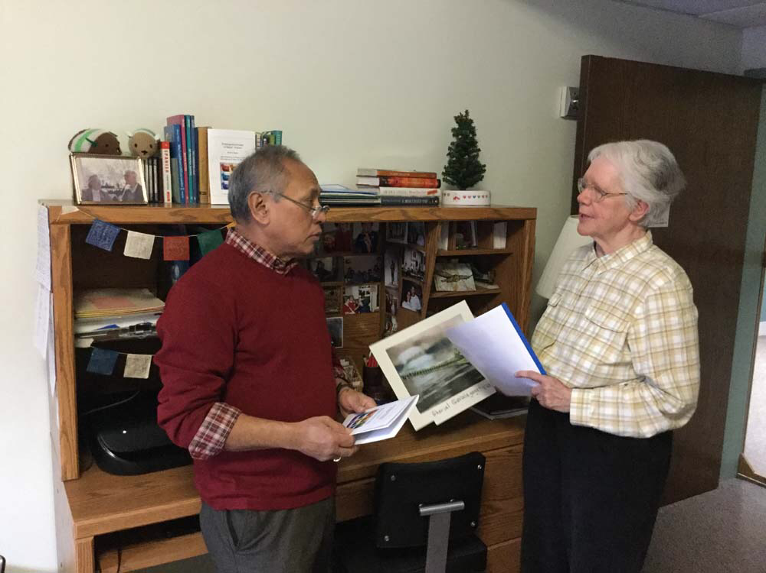

This poem also received an enthusiastic response from Jagadish, his wife and some of their visitors from Nepal. At that point I decided to look for a list of seriously endangered animals in Nepal, and if there were enough strange and unfamiliar ones on which I could find sufficient information, I would write a group of poems, perhaps for children.

Just as I located some lists of unusual and endangered animals, Nepal was hit by a huge earthquake. On April 25, 2015 a quake on the magnitude of 7.8 destroyed or damaged a large area around Kathmandu and killed more than 8,600 people and injured 21,000. The damage was widespread, destroying some of the rarest and most glorious monuments and buildings in Kathmandu and surrounding areas. Tourism in
Nepal, the starting place for climbing Mt. Everest and a popular spot for trekking expeditions, nearly came to a halt.

Jagadish was constantly trying to find out about his relatives and friends in Nepal. Daily he was getting "on the scene" reports, and I became absorbed in the news he was relating of the terrible suffering which people were facing. It occurred to me that if people had been killed, there must have also been a large number of animals killed.

At that time, I knew almost nothing about Nepal -- could barely locate it on a map. I thought that many endangered animals in Nepal must have become even more endangered by the earthquake. So I began my research.

By the end of May, I had written a total of 13 poems, all describing endangered animals which lived in Nepal. I decided to start with one poem, "The Pangolin", and query as many conservation organizations as I could find which listed endangered species of as their focus. Since The NY Times article had listed four organizations concerned with protecting pangolins, I began by writing a query letter: (addressed to the person listed on their website as communications director).

Following the Nepal earthquake, I started reading about the country and its
marvelous and unique wildlife. Inspired by a friend who is a native of Nepal and a zoologist, I researched the pangolin of which I knew little. Its characteristics and habits were so intriguing and humorous, I decided to put this into a poem.

I wondered if your organization would be able to use this in any of your
publications or educational and fund raising projects.

I consider this a donation to your organization which I hope will bring more
attention to your goals of protecting wildlife. I do not expect any payment.

Over a two-day period I queried 7 organizations, one of which was the International Union for the Conservation of Nature (IUCN) which was sponsoring a World Conservation Congress in Hawaii in September, 2016. Within a week, I received a reply from the IUCN saying that I was welcome to compete for a spot at the Congress by submitting a poster. This was impossible for me, as I would not be able to travel to Hawaii if my presentation was accepted.

Just as I was about to stop searching the internet for places to submit my poem, I came across an organization in California, which sounded like a long-shot prospect.

What most drew me to send a query was the fact there was a box asking me to "contact us" and there was a spot for a message. This made it easy to query and seemed to invite communication. I wrote a brief note asking if the organization,
The A-Team for Wildlife ( http://www.a-teamforwildlife.org ) would be interested in a collection of 12 poems for children. Since I had queried 7 organizations about the pangolin poem, I wondered if it was ethical to keep offering it when I had heard back from only one of the queries, so I did not mention it.

My message said, "I have been researching and writing brief poems about 12 of the most seriously endangered animals in Nepal.

I think these poems would be suitable for children ages 8 and up. I wondered if I could send them to you to look at.

I am a children's book author and a retired teacher. I am not seeking any compensation, just an opportunity to share these poems with as large an audience as possible.

*********************

Within 24 hours I received this reply:

Sure, Ann! Thank you for thinking of us! I will read them and maybe we can print them on our website in the kids’ sections.

Ken Jones
CEO, A-Team for Wildlife
Founder, former Director, Tropical Rainforest Museum
Producer/Host, Jungle Deep podcast
Career Profile available on Linked In.
www.A-TeamforWildlife.org
www.Facebook.com/AnimalsNeedMoreFriends
Ken@A-TeamForWildlife.org
209-225-9660
PO Box 1344 | Angels Camp | CA | 95222 | USA

That same day, I sent him by e-mail the 12 poems, along with this note: Attached are the 12 poems about endangered animals of Nepal. If you are interested, I have one more about the pangolin which I have not included. Let me know if you would like to see it.

Thank you for your interest. I look forward to hearing from you.

The next day, I heard back from Ken Jones.

Hi Ann,

Thank you for these. I have read only a few but enjoyed them and wondered how best to share them. How about we create an e-book by adding some photos or drawings of each animal? We could work with you on creating that, if you like. We could share rights on the book. We wouldn't sell it, but would give it away to new members and for promotions. Just an idea. What do you think? We have a few of our International A-Team Kids who are very good artists. I'll bet one or more of them would contribute the drawings.

If I have your permission, I will share one poem at a time on our Facebook page.
(I will always give you credit as the author).

Why leave the pangolin out? Please send. Thank you.

Ken

It was shortly after I sent him all 13 poems that I heard from Ken saying he thought the poems would fit in perfectly with a new school assembly program he was starting in the California schools to teach children about endangered animals. I expected that next I would be given a contract drawn up by a legal representative. To my surprise, Ken asked me to draw up a contract and send it to him. This seemed rather casual, but I wrote one based on some of the points which had appeared in previous book contracts I had signed.

***********************

Here is what I wrote:

June 4, 2015

A-Team for Wildlife.org

Agreement for publishing 13 poems about endangered animals of Nepal written by Ann M. Mayer

* I shall hold the copyright on the text of all the poems. They may not be reprinted without my permission.

* I shall receive credit as the author of each poem.

* This book shall first be published as an e-book. If, in the future, it is published in hard copy or paperback, all profits shall be donated to A-Team for Wildlife.

- Ann Mayer shall receive membership privileges for herself and one other person without cost for two years.

- Ann Mayer shall be given 2 copies of the e-book at no charge.

- The illustrations shall be obtained by Ken Jones. He may have the sole decision on which ones to include, consulting with Ann Mayer only if he so desires.

- Anything left out of this agreement which may in the future become contentious, shall be negotiated by both parties or turned over to an arbitrator if no resolution can be obtained between the parties.

****************

On June 4, Ken said: "Thanks, Ann! I will give this my attention very soon."

When nearly two weeks passed without a word from Ken, I became concerned that the wording of the agreement was way off base, and I would not know how to fix it. I had never had experience with e-books (except for reading them on my Kindle). Probably these presented a set of circumstances I had not thought of which I should have put into the contract.

I wrote Ken a brief note:

"Ken, I am anxious to know if you have had a chance to look over the tentative
agreement you asked me to send you. Can I assume that you have accepted the poems pending an agreement?"

Hi Ann,

"Yes, agreed. I have sent word out to our young members asking for their artwork, and have already received a few submissions. The kids are really having fun with this. I look forward to sharing them with you. I have set a submission deadline for the end of the month."

Ken

When the first week in July passed and I had not received the signed agreement, I once again wrote Ken. (6:25 pm July 9, 2015)

"Ken, I am excited about the poetry project and think it is on the way to a great debut. I have one concern to which I have not had an answer.

On June 3, at your request, I sent you a brief agreement.

On June 4 you responded that you "would give it my attention very soon."

On June 17 I wrote to ask if you had looked over the agreement, and had you accepted the poems pending an agreement?

June 18 you responded "Yes, agreed." You went on to say the children were illustrating the poems.

Your most recent communication said you had extended the deadline till July 11th.

You have never addressed the terms in my agreement. I would like you to do this before you proceed much further with the project. Did you read it? Is there someone else in your organization who is looking at the terms of the agreement? I would like to have some word from you before July 15, if possible. It is an interesting and worthwhile project but suffers from lack of communication between us."

That same evening, I received his reply:

Hello Ann!

I thought, "Yes, Agreed." would mean, "yes, I agree with your terms". Of course I have read them.

You seem to have some anxiety about this. Please let me know what your concerns are. I recommend a phone conversation. Please let me know how and when I may reach you by phone.

Ken

Again that same evening, I answered him,

"Ken, thanks for your prompt reply. I would welcome a phone conversation to clarify that our understanding of the agreement terms is the same. In particular, how do I go about getting the full membership benefits for two years? How do I obtain two copies of the e-book?

I would feel this was more professional if you and I each signed the agreement.

Exactly how do you plan to introduce the book? Will it first appear only one poem at a time on your Facebook page? Will the whole book be put together and ready to give out as a promotion? Who will get it?

You may reach me at home........ (Details as to time and phone#).
I would appreciate knowing the day and approximate time you will call so I will be sure to be home. Looking forward to "meeting you" by phone."

Ann

Ken and I scheduled a phone call for early afternoon on July 23

Before our conversation took place, however, I was surprised to receive a answer to my earliest query about the pangolin poem. Elizabeth John, Communications Officer of Traffic SE Asia wrote as follows:

Jul 14, 2015, at 1:45 AM

Dear Ann,

We received the email and the poem you sent to Dr. Shepherd with thanks.

Our office covers only the Southeast Asian region and therefore our work focuses on the Sunda Pangolin, but I will share the poem with other offices that may want to use it.

Will let you know if we do put it to use.

Best wishes,

Elizabeth John
Senior Communications Officer

I answered her promptly.

Dear Elizabeth,

I was pleased to get your response to my query letter to Dr. Shepherd about my pangolin poem.

Since writing this poem, I have found an organization which would like to use it along with 12 other poems about endangered animals of Nepal to be published as an e-book. It will be illustrated by the children who are members of this organization, which serves to educate children from around the world about endangered wildlife.

I propose that I write some poems specifically for your organization based on my research into endangered animals in parts of the world where your organization is active.

If you are interested, I would ask you to send me a list of 10 animals and I will choose at least 5 of them to put into poems for children which will convey the ecology of the animals and the threats they face. The poems could be done as a collection (about a specific region or country) or as individual "stand alone" poems. You would need to provide the illustrations.

I am not asking for any financial compensation, just written credit for the donation of my poems to TRAFFIC.

Please let me know as soon as possible, as I am just starting a new poetry project which I will put aside to work on yours.

I did not receive any further communication from Elizabeth.

*************************

I was not sure about the ethics of submitting a poem to more than one place at a
time. When I wrote some biographies for children in the early 1970s it was considered improper to send out a manuscript to more than one place at a time.

*************

On July 23, I was sitting by the phone waiting for Ken's call.

When I answered the phone, a friendly voice greeted me. Ken said that he had signed the agreement and it was ready to mail. He asked me to tell him about my background, and at this point we decided to include a brief biographical sketch and photo at the end of the book. As we were discussing my numerous questions, I could hear a dog barking as if greeting someone, and I thought to myself, of course Ken would have animals.

One of the first things I wanted to know was what the time frame was for finishing the book. We had never discussed this. I was quite astonished when Ken said he would hopefully have it done in 3 or 4 days (by July 27). I knew nothing about e-books other than how to download and read them, so my questions reflected my ignorance. How an e-book was produced was a complete mystery to me.

Ken explained that he wanted more children to submit illustrations for the book. He had put out a call to his A-Team but so far only 3 or 4 children had submitted a picture. "Some children did a picture for each animal." He had hoped for at least 8 submissions with some of them being from children outside the U.S. "I will send out another letter to the A-Team asking for more art and I will extend the deadline one
more week," he told me. "In the meantime, I will prepare a preliminary edition of the book to show you the format."

I wanted to know how he planned to introduce the book." It will be a gift to people who become new members or current members who request a copy," he said. "I am not looking to market it to the world at large," he continued. (I could hear a squawking parrot in the background). "We are launching our school assembly programs this fall. I can make the book available to teachers in the schools which book our assembly program." This sounded to me like a very good idea because we would know the target audience. Ken said he also planned to introduce it on their Facebook page.

One of my questions was how people would read the e-book. "It will be in PDF format," Ken explained. "This format is widely accepted so if they have access to a computer, they should have no problem". When I had asked him for 2 copies in my agreement, he told me he had laughed. "An e-book I can duplicate forever", he replied. Once Ken sends me a book, I can copy it as many times as I wish. He went on to say that I am free to distribute it to as many people as I wish. I could also get hard copies made, although they might be quite expensive.

Hard copies? This had never occurred to me. Do people generally dash off and get hard copies of an e-book? How expensive would this be?

On August 3, I finally received the signed agreement. I had not yet seen the preliminary book. That day I wrote Ken to say I had received the agreement and ask him when I could expect to see the first draft of the book. He replied:

August 3, 2015

My dear Ann,
I know you are eager to see what it looks like. Bless your heart. I am really looking forward to pulling this together. However, I just got back from 3 days in emergency with a brand new heart problem. I am firing on only one or two cylinders right now, so I am afraid more patience is required. I am so sorry. Maybe in a few days.

August 14 10:42 pm

Here is your draft!!!!

Hi Ann!

It is not quite finished but you have waited so long, I thought you deserved a peek. I hope you like it. I am waiting for a piggy picture to complete it - oh, and I am having a devil of a time formatting it in Pages as you will see. Don't worry. It won't be long now.

Thank you again for your contribution. I know the e-book will be well received.
Ken

August 14, 2015

One last picture needed for e-book

The e-book, Endangered Animals of Nepal, featuring your artwork is nearly finished and ready to share with you. Thank you so much for your beautiful contributions.
However, I am lacking just one picture. The poor little Pigmy Hog (Sus Salvanius) doesn't have a picture. Might you be willing to draw a picture of porky so that we may make our e-book complete? I need it right away.

You guys are awesome! Thank you!

Ken

On August15 Ken sent me a "first draft" of the e-book minus one illustration.
I was bowled over! It was so eye-catching and well laid out. I immediately sent Ken a note saying:

WOW!
Ken, I am so excited! The e-book surpasses my expectations. It looks so professional, colorful and appealing to children. It was such a wonderful surprise to get up this morning and find the book waiting on my e-mail. I can't wait to show it to my friends as well as Jagadish. He knows some teachers in Nepal and others there who will get a copy.

On September 2 at 1:13 pm, I wrote:

Ken,

I notice that my poetry book is being promoted in a very nice way on the Facebook page for your organization.

Have you had any requests for copies? Does this mean it is ready to send out?
Let me be first to request a copy!

Thanks for all your work and efforts.
Ann
p.s. I hope that you are feeling better. I am so curious to see people's reaction and comments. You and your A-team did a great job.
September 2, 2015

Hi Ann!

Glad to hear you are visiting our Facebook page. I try to provide current world environmental news and updates about A-Team for Wildlife there, regularly. No, I have not had a request for copies yet - you are the FIRST. I did send out copies to all our A-Team kids and inner circle of adults already. Here is a PDF corrected copy in a
reduced file size copy. I have a higher quality copy for printing, if you would like that. It is, however, very large - 22.7 MB. You know, Apple used to provide book printing services - just one-offs. I wonder if they still do. It was related to their photo software. It would probably be very nice (although pricey) to have one of those!

Ken

On September 3, I received a high resolution PDF of the book (21.6 MB)

Part Two

New Plans for the Book

My first thought on seeing this e-book "Endangered Animals of Nepal - Poems" with their eye-catching illustrations was, "I must find a way to get this book to Nepal's school children".

By chance, the next week a friend gave me some back issues of The NY Times Science Times for August 18, 2015. My eyes immediately fell on the front page article "Adorable, and Vulnerable" by James Gorman. (http://nyti.ms/1DXMHHO). The appealing photograph of a little red panda was enough to get most people's attention.

One of my poems was about the red panda, so I eagerly read the article. Now I was looking for some connection in Nepal which might help me achieve my goal of finding a way to get my e-book into schools.

The NY Times article mentioned that the Red Panda Network. http://www.redpanda.org.np/ had an office in Nepal, so I looked on the Internet to see if I could find a contact person and an email address. Success! I found two people: Ang Phuri Sherpa, Nepal Director of the Red Panda Network, and Damber Bista, Program Manager. Both had e-mail and were located in Kathmandu.

On September 8, I sent the following e-mail:

I recently read the NY Times article from August 18 entitled "Adorable and Vulnerable" by James Gorman.

By coincidence, I just had the attached book of poems for children published as an e-book by the A-team for Wildlife. I am looking for ways to distribute the book in Nepal, as I wrote following the earthquake, especially for the people there in sympathy for their plight and that of their wonderful wildlife.

I would like to find a way to get it to some teachers who might use it in their classroom.

I would welcome your help or suggestions as to how I might distribute it. There is no charge for the book and I can send a copy to as many people as I wish.

On September 9 I received this response from Ang Phuri:

Dear Ann,

Thank you so much for your thoughtfulness. We at the Red Panda Network are delighted see the poem book dedicated to people of Nepal and its endangered animals. Congratulations to you and entire A-TeamForwildlife.org on the publication of this Book. It is very interesting to go through the entire poem book with wonderful art work. I am sure that this poem book will be very helpful in educating young minds and inspire them to learn more about the plight of so precious and exotic animals. We have 27 Roots and Shoots group affiliated to our organization in Eastern Nepal. We would love to receive 150 copies, if possible posted to address below.

Red Panda Network
PO. Box: 2785
Baluwatar, Kathmandu
Nepal
Tel: +977-1-4415745

Thank you once again for all your support. If it is possible to send more copies you are most welcome!. We will distribute among numbers of schools elsewhere in Kathmandu and Terai Areas.

Best Regards,
Ang

That same day, I replied to Ang Phuri with a cc. to Ken Jones saying:

Thank you for your prompt reply and your offer to help distribute the poem books in Nepal.

I am not able to send you any hard copies, as I have donated the book to A-Team for Wildlife and I have no funds to produce hard copies to send you.

I would be able to send you a high definition PDF file which could be used to make hard copies. When I offered to send you multiple copies, I meant a high-quality
e-book file sent to the personal e-mail of teachers or schools, if you can provide me with these addresses. I am not sure if such people would have e-mail and if the children would have the computer software needed to view the book.

The A-Team for Wildlife is an organization in California with goals similar to those of Roots and Shoots. It is using the poem book to help with fund raising so I would not want to do anything to compete with them. However, I do not think they have any contacts in Nepal.

I am forwarding your e-mail to Ken Jones, the Director of the A-Team for Wildlife.
Perhaps you could work together in some way since your goals are similar.

Ann

September 9, 2015

Dear Ann,

It is ok if you cannot send us hard copies. We would be happy to coordinate in Nepal if Ken is able to send us available copies. I was asking for hard copies because all these school groups has no access to e-mail..internet… computer facilities as they are located in highly remote areas. If they are able to receive hard copies then they are fortunate enough.

Thanking you
Ang Phuri Sherpa

Part Three

Funding -The Search Begins

I wondered what it would cost to get hard copies printed in Ithaca. If they were inexpensive enough, perhaps I could mail some to Nepal. It had never occurred to me to get a few hard copies just to keep and show people.

I contacted a local printer to find out the cost of a copy on inexpensive paper, 81/2" X 11". It would be about $3.00 a copy (if there were no sales tax added).
I asked about discounts for multiple copies printed without using card stock paper.

Prices with tax were: 150 copies $ 455
200 copies $ 607
300 copies $ 910
500 copies $1518

I decided to get 6 books printed cheaply for myself, and I paid $3.21 per copy.

Then I contacted Pack N Ship and spoke to an expert on mailing things to remote countries. She said Fed Ex was the most reliable, but there was still no guarantee that the items would arrive safely. The cost of mailing would be about $525.
It seemed that the best thing to do would be to find a way of getting copies made in Kathmandu or some other city in Nepal and then distribute the book via people who live, study, or volunteer there.

I sought Ken's advice. On September 18, I wrote:

Ken, my book is meeting with a great deal of interest and approval from those to whom I have sent it.

I am wondering how I would go about finding a corporate sponsor to pay for some hard copies for Nepal. I have looked into the cost of having the copies made here and mailing them (by Fed Ex) which is the impost reliable way, and I find the cost of mailing is twice the cost of the books. The printer I used would charge $455 for 150 copies, $607 for 200 copies, and $843 for 300.

Do you have any experience with obtaining corporate support for a one-time project like this one? Is there anyone on your Board who can apply for such funds?

I researched the Coca Cola Foundation, and they might be a good prospect, but they do not give grants to individuals, only to 501 3(c) non-profits. I have done grant writing and would be willing to try for one if you consider this a good idea.

If there is a way to get them printed in Nepal, this would save a lot of money which would mean we could get more books for our dollars. It does not seem right to me to offer the people in Nepal the book and expect them to pay for it.

Ann

Ken's reply on September 18

Hi Ann!

Your printer is charging only about $3 per 26-page book. The ticket would be to find a company doing business in Nepal, with offices there, to provide a grant for printing and distribution. Google can help you with that. I would start by searching for business associations in Nepal. Do they have something like our Chamber of Commerce? Are you wanting to distribute it primarily in Nepal? You want to talk to the marketing people at any business you approach. Offer to put their name on the book. Be patient and persistent.

A-Team for Wildlife has no financial resources or connections - yet. Our fundraiser fell well short of our goal, just to cover basic expenses.

I want a printed copy to show at the schools I am going to (but can't afford it yet).
Wish I had more to offer. Good luck. Keep me up to date. Ken.

Thus, I was on my own. I followed Ken’s advice to try obtaining a one-time corporate grant or donation of $1,500. First I made up a list of 15-20 corporations which had offices in Nepal.

I started with Coca Cola. When I called the information line for grant information, I was told that any grant applications to be used in a foreign country must originate in that country, and that I should contact the bottler in Kathmandu. I wrote them a letter but I never received a reply. I wrote letters and sent e-mails to at least 12 organizations and corporations with offices in Nepal or which had an interest there. Only one replied.

As I went through the list of possible businesses to contact, only one or two seemed likely prospects. Most of them, such as GE, Federal Express, Kentucky Fried Chicken, Pepsi Foundation, Zenith Technology and Apple gave preference to applications from employees or their family.

Next I looked into non-profit organizations, and contacted WWF Nepal, Lions Club International, Room to Read, Asian Pacific Library Assoc., TESOL (Teachers of English as a Foreign language, Save the Children, Nepal Youth Foundation, Educate the Children (ETC) based here in Ithaca. No luck.

Then I had the idea that perhaps I could find a printer in Kathmandu who would print them free as a donation to the schools. I consulted my iPad directory of printers in Kathmandu, found three and sent off letters.

One replied (http://www.sbprinters.com.np) that they would like to see the e-book so they could figure out the cost of printing copies. They were enthusiastic about the book and offered to print 500 copies, donating the cost of their labor and charging me only for the materials which would be $700.

At first I hesitated because this seemed like a lot of money, but I realized this would cost me $1.40 per copy, whereas in Ithaca it cost nearly $3.50 per copy. Also the specifications the printer in Nepal described were more desirable for a child’s book than the folded, stapled 8 ½ x 11 sheet of paper used by the local printer. The listed the specifications as follows:

Book size: 21 cm X 29.7cm
Book cover: 250 gm art board (hard cover) multi- color print with lamination
Inner page: 24 pages: 130 gm Matt art paper (semi glossy), multi-color print(CMYK)
Binding: center stitch
Cover lamination: gloss lamination.

This printing company sounded like a good prospect for several reasons:
* It had a website which was easy to navigate.
* It listed schools as one of its clients.
* It listed books as one of the items it printed.

The website gave a lot of information, the owner's name, address, e-mail, phone number, a list of clients, types of jobs it was prepared to do, and a form to request an estimate.

On October 6, 2015 I sent an e-mail letter to the manager/owner describing my project and asking if he would donate some of the costs of printing the poetry book.

An answer came the same day (but one must take into account that the time zone is quite far ahead of ours. When our clocks in Ithaca, NY say it is 3:30 p.m. on a Monday, it is 1:25 a.m. on Tuesday in Kathmandu). This fact made it interesting to send correspondence, because I could write a letter just as I was going to bed and I might have an answer waiting for me in the morning.

October 6, 2015 3:42 a.m.

Dear Anne Mayer,

We would to like request to send us your e copy design sample and detail. According to your offer we only can sponsorship only printing service only Paper and Material cost will be charged on bill. If you are interested to print in material cost please send us your e book for calculation of cost.

With Best regards

Shyam Sundar Gaihre

I was thrilled to get a welcome response. Of course I immediately sent a copy of the book.

On 6 October 2015 at 19:06, I wrote to Shyam Sundar Gaihre

Please calculate the cost of printing 500 copies in color. The size should be 81/2 by 11" when the sheets are folded. I would prefer that the cover be printed on heavier (card stock?) paper. The cover would be the title page, blank on the back. Inside the back cover would be my biographical information and the back would be blank.

Would you kindly do a calculation for the cost of printing with card stock cover and another for a lighter weight cover. In my letter of Oct. 5, I requested a donation of
$1,000 (US) for the printing of 500 copies. I need to cover both the cost of printing and the cost of materials.

The Red Panda Network asked for 150 hard copies. Ang Phuri Sherpa offered to coordinate the distribution of hard copies in Nepal.

What would the cost be if you were to donate both the cost of printing and the cost of materials for 150 copies? I hoped to get 200 or 300 copies so there would be enough to distribute more widely in Nepal after the children get back to school.

Let me know what you are able to contribute for this project. I am most grateful for your help.

Ann Mayer

October 6. 9:36 am

Dear Ann Mayer

I would like to request for inner page count also.

Shyam

October 6. 10:09 am

Dear Ann Mayer

We Received your all detailed information and e copy of book. It Costs $700 for Production Material for 500 copies of book.
We are ready to produce and handover your book at $700.

Shyam

On October 6, 2015, at 7:52 a.m., Ann Mayer wrote:

I am so pleased that you are willing to make this wonderful contribution to the children in Nepal! The book specifications you described sound elegant. I am sure it will be appealing to children who may not own any books.

I am forwarding your offer to Ken Jones, who produced the e-book for his non-profit organization. I want to be sure your company's name is included in the book. Please do not make the copies until you hear from Ken.

I am also forwarding this to Ang Phuri Sherpa at the Red Panda Network, as he is the volunteer who will distribute it. I will ask him to get in touch with you to coordinate this.

Would you be able to send me 3 copies of the book? I will mail one to Ken and keep one, and give the third one to someone who helped me with this project. There are people from Ithaca, NY where I live, who come to Nepal, so if you prefer, I might get one of them to bring back 3 copies.

Thank you again.
I will be in touch.

Ann

**********************************

Ken responded to Shyam's offer by clarifying several points about the offer.

October 6. 11:53 am

Hello Ann,

I have gleaned from this set of emails that you have found the printer in Nepal to print your book. It appears that he is donating his printing services but is asking for $700 for the materials, and so, you want his business printed somewhere in the book as a sponsor. Is this right? Do you have a sponsor for the $700 as well? Shall they be listed?

I will be happy to add sponsors as you wish, and make a new pdf for the printer. I need to know exactly what is to be said.
Ken

At first, I was hesitant to commit myself to paying $700 for printing the book when I had no idea where the money would come from. When Ken pointed out that this was only $1.40 per book, I realized what a good deal this was. I knew that I would somehow need to figure this out. I e-mailed the printer in Nepal and said YES to his offer.

Next, I composed a letter explaining my project and how much money I needed to raise. I began with people I knew here at Kendal. For several years as a hobby, I have been knitting stuffed animal toys. I had quite an inventory built up, so I decided to sell these and use all the funds to help pay for my project. I displayed the animals by carrying them around on the handles of my walker everywhere I went.

As soon as people became aware that buying the animals helped finance my book project, they readily ordered and purchased animals for their grandchildren, nieces, nephews and even for themselves. I offered to make special ones to order (perhaps by putting a scarf using specified college colors on the animal, or letting the buyer choose the colors of the felt for lining the ears and feet). Each person who donated money or bought an animal received a "thank-you" note saying how many books their donation would fund.

I wrote to my friends and asked for donations, some in lieu of a Christmas present. I
told the editor of my college (https://www.mtholyoke.edu/ttps://) class news
column to mention it, if possible, in the next Alumnae News column. She suggested including it in the upcoming Class Letter. Another former college classmate put me in touch with a recent graduate from Nepal who had won the 2014 Miss Nepal USA competition (http://missnepalus.com//profile.php?id=2054). I sent her a copy of my book and asked if she had any ideas for obtaining funding. She took an interest and made some suggestions. I received donations from $1.00 to $100.00.

Then I heard about a local organization founded in Ithaca and still active called “Educate the Children” (ETC) ( http://www.etc-nepal.org )which works with
schools in Nepal. There are people from Ithaca who go back and forth to that country regularly.

With this in mind, I thought that ETC, since it is based in Ithaca, would be an ideal organization to act as distributor of my book of poems.

One of the former Board members of ETC who lives here at Kendal was able to put me in touch with the local director, Lisa Lyons, who was knowledgeable about how to send funds to a foreign country. In order to pay for the printing, I would need to transfer $700 US dollars to Nepal. As I thought about this, I realized that I could not pay the entire cost up-front. I did not have anyone on hand in Kathmandu to check on the printing before making the final payment. I talked this over with Lisa Lyons. She said that to send money to another country requires making a wire transfer and each transfer costs about $50. It would be nice if I could make just one payment. If I had a person in Kathmandu to receive the funds and check up on the printer, I could, perhaps, get away with making only one full payment.

In the meantime, Lisa had said she would ask a colleague for information about the printer, since I had chosen this company merely from an ad on the internet.

Here is what Lisa said:

December 1, 2015

Hi again, Ann,

My colleague reports that the $700 estimated cost for 500 copies is fine if it is in four colors. She thinks that that particular printing company has a good reputation, although she has not personally worked with them. She is not familiar with, i Red Panda (Network).

ETC may be able to help distribute some of the books in the schools with which we have relationships, if that is helpful. Who is your target population? The younger kids probably would not have the English skills to read the poems very effectively, but the high school students might. If nothing else, perhaps the school libraries could use some copies.

I hope that information is of some use to you. What are your next steps?

Prior to my conversation with Lisa, I had met another ETC volunteer who said that Beth Prentice, President of the U.S. Board of Directors, was going to Nepal shortly and would take a copy of my book with her.

On Nov. 13, I wrote to Ken saying:

Ken, I have received individual donations amounting to $604 toward the $700 I will need to get the poem book printed in Nepal. At this time there is an officer of ETC from Ithaca who has gone to Nepal and taken the book to show their education director. I am hoping they will agree to help distribute it. They have said that they are not able to offer financial support. I am expecting to hear in the next couple of weeks, as she is due home on Nov. 19.

Once I know who will distribute the book, I can send you the acknowledgements to add to the book, and then you can go ahead and get it ready for me to e-mail to the printer in Nepal. I hope this is not a difficult job. It would be nice to get it done before Christmas since my friend here knows someone in Nepal who is coming to Ithaca for Christmas and perhaps could bring me some copies. Then I can send you one.

Ken replied:

Hi Ann! Sounds good! What a networker you are. You are terrific.

Several people called my attention to the fact that Cornell University has a Department of Asian Studies which teaches Nepali language courses throughout the year. Cornell students and professors go to Nepal as part of the language course. The following is a description of the course taken from the Cornell University website.

“The Cornell Nepal Study Program" is a pioneering joint venture between Cornell University and Tribhuvan National University of Nepal initiated in 1993. (https://www.youtube.com/watch?v=yEXel2g-T8s)

Courses are taught in English at the program facility and the main Tribhuvan campus in the medieval town of Kirtipur, near Kathmandu, by Nepalese faculty from the Tribhuvan University Departments of Botany and Sociology/Anthropology. CNSP is the first and only study abroad program in Nepal to draw together students from American universities to live and study with Nepalese peers in residential program houses.”

December 3, 2015
In a letter to Lisa Lyons, I asked if she could find out if there is someone in the ETC office in Kathmandu who would be able (without hardship) to visit the printer.
It would also be helpful to have the name and phone number of someone in that office who could be a contact for Ang Phuri Sherpa from the Red Panda Network in case he has any questions about where ETC is going to distribute the books.
Lisa said that she would find out from the Nepal staff what the feel they have time to do properly.
I don’t want to assume, for example, that it would be easy for them to get out and check at the printers. I checked the map and the printer is near the south end of the airport about 5 km from the ETC office, and with the fuel shortage it is very hard to get anywhere these days (taxis are more expensive, buses not running as frequently, etc.) But I can find out. Perhaps one of our staff members lives near there.
If ETC provides some of the books to school libraries, it could be in the Dolakha District where we are now doing the bulk of our work – that wouldn’t conflict with the areas that Red Panda is already doing.
In at least some schools, they do start teaching English at the primary level, but it’s pretty basic. So yes, the older kids would certainly get more out of your book from a language point of view, but you are right that anyone can enjoy the illustrations, and perhaps if the book were available in a school library, that could be a way for older kids to reinforce their skills by reading and translating for younger kids. I mean just on an informal, one-on-one basis.
In further communication with Lisa, I told her that my next step will be to decide how to pay the printer a down payment and a final payment without having to wire 2 separate payments to Nepal. Each wire transfer costs approximately $30 which I would have to pay. If I could avoid sending two payments, I would be happy. Before I gave the printer a final payment, I had hoped to find someone who could look at the finished books and be sure they had met the specifications. Ang Phuri Sherpa from the Red Panda Network had offered to help distribute books, but I hesitated to ask him to also pick them up at the printer.

Dec 4, 2015
Time to communicate once again with Ang Phuri Sherpa.
Greetings!
I would like to update you on the progress of getting my book printed for distribution in Nepal. I have raised the funds needed for printing 500 copies. I have found a printer who will do the job. I have a few details to work out.
I want to give your organization a written credit for helping me. Is there a particular wording you would like? May I say: "I would like to thank the Red Panda Network in Nepal for helping to distribute copies of this book in Terai and Kathmandu."
The organization, Educate the Children (ETC), will get 242 books to distribute to the schools where they work in Dolakha. I will get you the name of a contact person in their office in Nepal, and an address.
You will get 250 books to distribute in Terai and Kathmandu. I would like the books to be given to school libraries, where possible. I think more children would have access to them if they were in a library. However, I would like you to use your judgement as to where to distribute them, since you are familiar with the country and the needs of the children and teachers.
Are you able to pick up the books which you are distributing? Will you have expenses associated with distributing the book? Am I correct that you will donate your services in turn for recognition in the book? I will make a donation to The Red Panda Network if I am able to raise more money.
I will be in touch again soon when I have more information. Thanks so much for your help.
Ang Phuri replied:
Dear Ann,
Thank you so much for Update!. It is wonderful news that you have arranged to print them. Yes, the wording sounds fine to me and you can also say that RPN will distribute also in the mountain areas. I think we will be sufficient to receive 250 copies. We will definitely manage to pick up the books from the printer you have suggested. There is no associated cost for distributing the books. And thank you so much for your positive note on donating RPN in future. Please let us know when the books will be ready.

Wanting to pursue every possible source of funds, I wrote to the Nepal Youth Foundation to see if they would be able to provide $400 toward the printing cost (which at that point was all I needed) and to ask if that organization could help distribute the book to schools in Nepal. Their reply was:

Dear Ann,
This is absolutely beautiful piece of work what you created. Sadly, NYF
doesn't have any fund to support such work, neither we have network to distribute the book. However, this is exactly the kind of projects what WWF funds. Please write to WWF Nepal. I am pretty sure they will be delighted to support your work.
Regards,
Som
SOM PANERU |PRESIDENT
NEPAL: Ekantakuna, Bhanimandal, Lalitpur, GPO Box 10012, Kathmandu
Following up on this lead, I wrote to Simrika Sharma at the World Wildlife Fund in Nepal.
I received this reply:
Thank you for your email. I am currently on travel and will be able to get back to you only after 13 October. Kindly contact Shikha Gurung at shikha.gurung@wwfnepal.org in case of emergency.
Simrika Sharma <simrika.sharma@wwfnepal.org>
Nearly two weeks later I heard back from her.
Dear Ann,
Apologies for the delay made in getting back to you as we were having a Dashain break.

From what you have mentioned, the book should be interesting. Could you please send me a sample copy so that I can forward it to the team for the review here?

I will get back to you shortly after that on whatever our decisions may be.

Best Regards,
Simrika

There was no further communication from her.

************

On December 4, I wrote to Ken that I had prepared the wording of the acknowledgements I wanted him to add to the e-book before it was printed. I had cleared this with each organization which was to be recognized.

I pointed out a couple of places in the poems which needed reformatting and asked him to send me a revised high resolution PDF file which I could send to the printer.
Then I feel I am READY TO GO.

By mid-December I became concerned about Ken, as I had not had any communication from him in a couple weeks. I sent him an e-mail.

Ken, I am wondering if you are away or not feeling well, as I have not had any response to my last 3 e-mails. As I mentioned, I have everything in place to send the e-book for printing in Kathmandu, Nepal. I have written an acknowledgement (and revised it several times) which I would like included.

I am attaching it for you to look at and tell me if it is satisfactory. Perhaps you have already written one, as I suggested a different wording. If you are not feeling well or are unable to get to the revisions, would you give me permission to go ahead on my own, have the printer include the acknowledgement I wrote, and then go ahead with the book printing?

I will try to phone you tomorrow (Thurs.) about 1:30 p.m. EST (our time), if I have not heard from you. I am uncertain of my schedule tomorrow so I am not certain I will be able to call. Thank you for your help. Everyone who has seen the book is MOST ENTHUSIASTIC. Ann

The following email came from Ken the day after I sent the one dated Dec. 16.

Hi Ann! I am sorry but I have terrible news. The A-Team computer died this week. I cannot access the drives in the computer that holds any A-Team Files, including yours, until next week. I and A-Team, are essentially "out of business" until I can find the funds to have it repaired - I am looking to raise a few hundred dollars for computer repair. My access to email and phone messages is, for now, dodgy. Maybe you can create a fundraiser to help us out with a contribution? For now, I have no way to provide you with what you need. I am so sorry. Terrible timing.

Ken

Part Four

Links

Suddenly, due to a chance encounter on a plane to Nepal, everything began to fall into place. In November, Beth Prentice (from ETC here in Ithaca) had taken a trip to Nepal, bringing my poem book to show the ETC education director there. She happened to be seated next to a gentleman from Nepal who worked for the World Wildlife Fund and shared many of her interests.

As they chatted on the long plane ride, it occurred to Beth that her new acquaintance, Ugan Manandhar, might be able to help distribute my book. On December 11, Beth sent Ugan this e-mail.

Hello, Ugan. It was lovely to meet you on the plane in Nepal. I am home now. I hope all is well with you and your family.

I want to introduce you by e-mail to Ann Mayer, the person I told you about who has written a beautiful poetry book about the effect of the earthquake on some of Nepal’s endangered species. She is now working with a printer in Kathmandu to get it printed. It will be distributed primarily through the Red Panda Network. Educate the Children (the organization with which I am affiliated, called ETC) will distribute it to classrooms and libraries where we work.

As your job at WWF is so intimately connected with Nepal’s endangered species, I thought it would be quite useful to put you and Ann in touch with each other. WWF in Nepal may also be interested in helping to publish and distribute this book in Nepal?
It was quite a novel experience for me to be introduced by e-mail to someone I had never met. I received this welcoming letter from Ugan (as a cc: to one he wrote Beth) on December 13.

Thanks, Beth for introducing us. I have written to Ann. I am ready to help her.

I am heading to Kathmandu after attending the climate conference in Paris and will arrive tomorrow. I also know Ang Physician Sherpa at the Red Panda Network. (Another coincidence that proved helpful. My comment.)

Ann, A very nice book, indeed.

Ugan

It turned out to be Ugan who was a major link in the chain of people who helped me get the book printed in Nepal. Two of my major concerns were getting someone to interface with the printer and approve his work before I sent the payment, and the other was finding someone who could pick up the books from the printer when they were finished.

After I described the project to Ugan in detail, he readily agreed to check on the printing after it was completed. Red Panda Network’s Ang Phuri Sherpa had already agreed to pick up the books.

Lisa Lyons and I had corresponded several times about the details of transferring $700 to the printer. On December 4, I had sent her a copy of the acknowledgement I was having printed in the book, to seek her approval. She said it was fine. At that time she was trying to help me find one of their staff members to check on the printer and turn over the funds when the book was ready. It soon became evident that it would be best for me to send the payment directly to the printer in two wire transfers.

One of the reasons for making two payments, Lisa explained, was that if ETC “receives money, for whatever reason, it has to be for a purpose indicated in our multi-year agreement with the Nepal Social Welfare Council, the national government agency that generally oversees all our kind of work. So it would mean having to formally amend the agreement, which is a big hassle, and it would mean putting your funds through the formal audit system, which is also a big hassle.”

In order to wire money from Ithaca to Kathmandu, I had to get the following information from the printer:

- Did he want the funds to be in dollars or Nepali rupees?
- The name of the bank where the funds would be sent.
- The address of the bank.
- The bank account number.
- The routing number.

Everything seemed ready to go, except I did not have a final updated copy of the book from Ken. His computer still was not fixed. I asked him if I could go ahead and add the acknowledgement myself and send it to the printer. That was the only change which needed to be made to the e-book file. I called a local printer to ask if it was possible to add this paragraph to the e-book without having the original file. He said yes, and did not charge me for making the change.

On December 17, I sent the “final” copy of the book to the printer. I told the
printer that I would wire the first payment of $350 on December 22. It would probably take at least two days to receive it, and because of the Christmas holiday it might take longer. I did not hear from the printer that he had received the e-book so on December 19, I asked Ugan to check on whether the printer had any problems or questions about the book. “Would you ask the printer when he expects the books to be finished?” I knew that if they were ready before the end of the Christmas holiday, Jagadish had a friend coming from Nepal who might be able to bring the books directly to me.

Things seemed to be proceeding as planned, and naturally I was very eager and impatient to see the final book.

December 22, 2015

It was a chilly, gray Tuesday. I took the Kendal shopping bus to the Tompkins Trust Bank nearby to do the wire transfer of $350. I was uncertain about how much time I would need for the paperwork involved. Fortunately, the bank was not busy and a competent young Hispanic woman took care of the papers I needed to fill out. She wanted to know what I was sending the money for. I told her that when I came back to send the second payment, I would bring a copy of the poetry book to show her.
She seemed very interested. It took nearly ½ hour to finish the transaction and the bank official, being very efficient, said she could make out all the paperwork for the next transaction, so I would save time when I came back a second time. The only part she could not fill in yet was the value of the Nepali rupee to the US dollar. I was concerned that the printer might not receive the full $350 if the value of the rupee dropped, and also because his bank would charge a fee for exchanging the money.
I later asked Shyam if he had received the full value and I offered to reimburse him for any bank fees he had to pay. He reported honestly that he even made a bit of extra money because of the value of the rupee to the dollar!

Dec. 28, 2015 10:30 pm

Ann,

My computer is now fixed. Is there anything I can do for your book printing at this late date?

Ken.

Dec. 30, 2015

From S.B. Printers

Dear Ann Mayer

Thank you very much for your advance payment. Today is bank holiday so we will confirm tomorrow. Please ask Ken Jones to Prepare File Separate Page PDF file and Color Mode “CYMK”

With best regards,
Shyam Sundar Gaihre

January 2, 2016

Here is the low resolution version 6.r for computer/internet sharing.

Ken

January 2, 2016

Ken sent a high resolution version of the book.

Ann,

Here ya go! Let me know if it is O.K. or if you need another revision. Would love to have a print copy for each of the International A-Team Kids who contributed: Aidan, Carly, Avalon, Olivia, and Cooper. Perhaps you could autograph a brief message to each of them on their copy. That would be extra-nice. Send them to me and I will ship the books to each of them. No hurry.

A few problems and glitches held up the printing for awhile.

I wondered what Shyam meant when he said “convert the file from RGB to CYMK.” I did some searching on the internet to find out if this was an easy process and if most printing companies could do. It seemed as if they should be able to. I called two different printers in Ithaca to ask if they would be able to do this and one said yes. It then occurred to me that probably SB Printers in Kathmandu could do it!

Here is Ken’s reply.

January 13, 2016

Dear Shyam,
O.K. It appears that photoshop can do the conversion of RGB to CYMK, but only one page at a time. I don't see an option to convert the entire document at once in Photoshop.
The standard practice is to do the conversion in Adobe Acrobat Pro. However, I do not have a copy of that software.
It appears I do not have available the capability to do the conversion from RGB to CYMK.

Ken

Here is Version 8. Is this more like what you want?

On Jan 16, 2016, at 10:10 am
Ken wrote:
I have not heard back from Shyam after sending him my revised copy containing *most* of the changes requested. I assume from this email that it was acceptable and that my duty here is done. Please advise is something more is needed that I may supply.
Good luck with the printing!
Kind Regards,
Ken

I wrote to Shyam.
January 14, 2016
Since Ken is unable to convert the file from RGB to CYMK, is this something I could pay you to do? If you need to have the conversion done and you have the necessary software to do it, let me know what the added cost would be. Do you think this conversion is necessary?

January 16, 2016
I wrote once again to Shyam.
I am wondering if you can make the remainder of the changes needed to prepare the poetry book for printing. I would pay you if the extra cost is an amount I can handle.
If you are NOT able to make the additional changes, please let me know and I will try to find someone here who can do them. It is my understanding that the only remaining change is to convert the file to CYMK. I know that some printers are able to do this.

January 16, 2016
Dear Ann Mayer,
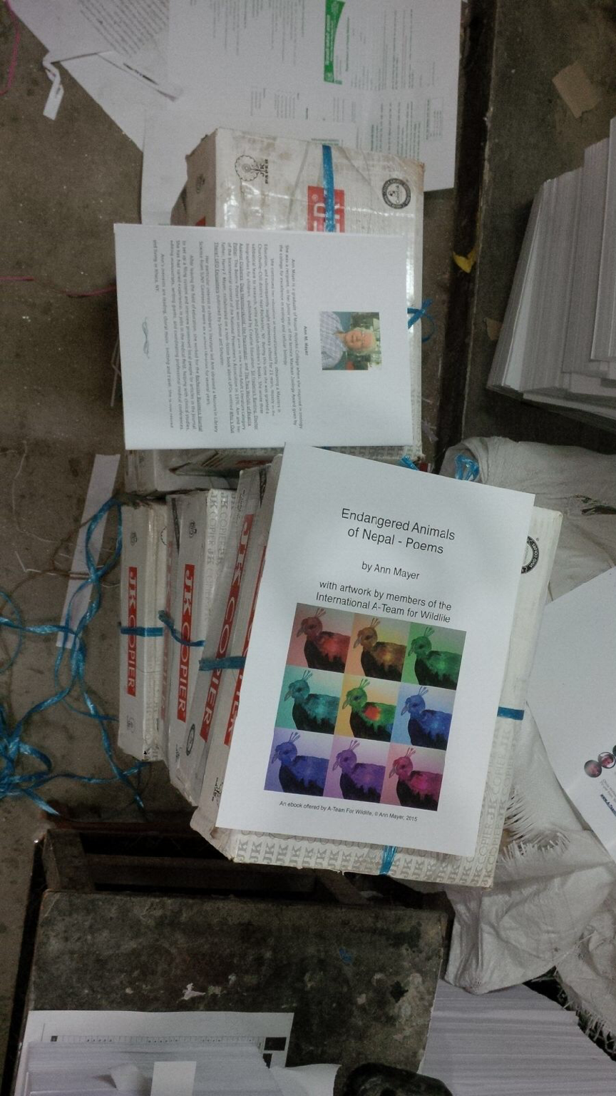
I prepared your file for printing in CYMK Color Mode and picture yesterday but I forgot send you a copy for final conformation (confirmation). Saturday is our Holiday. So I will send you Sunday first hour in Nepali time. If you give me permission for printing. We will start Printing from Monday 18 Jan. I'm extremely sorry for delay to sending edited file copy
With Best regards
Shyam Sundar Gaihre

Above is a copy of the photo Shyam sent me to show that the printing was complete.

In my search for a way to get some copies of the book for myself and to find places to distribute them in Nepal, I made two other contacts.

- Michael Hess: Founder of Nepal Orphans’ Home
http://www.nepalorphanshome.org/.

A former classmate from Mount Holyoke College gave me his name and told me he would be interested in seeing my book. The orphanage he manages has 4 houses in Dhaposi and a school – Skylark English School.

When he saw my poetry book, Michael was supportive of my effort to get hard copies to children in Nepal.
.

Jan. 3, 2016

Dear Ann,

This is a beautiful book! I have not read it all but the illustrations are endearing.

With the WWF behind you I am sure you do not need any distribution advice. I will print out a copy now to share with our book club and when you publisher prints them, I will buy copies for each of our homes. Please let me know when you go to press.

Thank you so much for sharing and please let me know if I can help I any way
not yet discussed.

Michael Hess.

When I told Michael that I was not asking anyone to pay for their book, he insisted on giving a donation to help us with printing or distributing costs. I suggested that he send a donation to A-Team for Wildlife. He did so immediately and told Ken that “his website is excellent.”

Ken thanked me “for the little promo, and sent the following note to Michael.

Mon, Jan 18, 2016 at 6:42 AM,

Thank you! Thank you! May I thank you publicly with a posting on our website and Facebook page? By what name shall I list you?

Jan. 18, 2016. 3:37 am
Dear Ken
Our donation was rather humble however we will be keeping an eye on your work and maybe can be more helpful at a later time. I have copied some of our board members so that they can read over your website and we can discuss it after.
You are doing wonderful work to say the least, your life must be a very pleasant one because of it.

You are more than welcome to acknowledge this online;

We are simply: Nepal Orphans Home. Dhapasi. Nepal

All my best;
Michael

Tues. Jan. 19, 2016

Ken wrote to Michael:

Thank you for telling others about A-Tea, For Wildlife. We are new and struggling to build start-up capital. I do get to do wonderful work. I am inspired every day by our International A-Team kids. I am always on the lookout for exceptional children working for wildlife – should you learn of such a child in your area, please nominate them for the International A-Team.

It will all become more pleasant when I know we can pay our bills and grow in our efforts to reach children with our conservation message. Our new Patreon page offers a good summary of our cause, our work, and our goals, all on one page.

http://Patreon.com/A_TeamForWildlife

Michael sent these words of encouragement to Ken.

Hang in there, you are going to be successful with this, you already are, but more so. Your personal approach is key. It shows your personality, heart and commitment. I appreciate what you are doing.

- Niyeti Shah: Development Assistant for Blink Now Foundation http://www.blinknow.org

A second valuable connection in Nepal came from a CNN TV program about the 2015 “hero of the year” award.

The winner of this award was Maggie Doyne, a young American woman, who founded the Blink Now Foundation. I learned that the Foundation has an orphanage in Surkhat (Nepal) and is building a state-of-the-art school nearby.
The Kopila Valley School offers a diverse curriculum and children start learning English in Nursery School. The description of the new school building said it will have a computer lab and that all the children speak English.

I wrote to the Blink Now Foundation and was put in touch with Niyeti Shah.

Just before Christmas I sent her an e-copy of my poetry book. She wrote that she had difficulty opening the file, but when she succeeded, she praised the book highly.
,
Here is my first letter in response to her questions about the book.

Niyeti, I am so glad to know you were able to open it!!
I would be happy to have you print several hard copies and keep them in the library.
I have been fund raising here to pay a printer in Kathmandu to print 500 hard copies which will be distributed in several regions of Nepal where the organizations helping me have contacts. It will be about 8 1/2 x 11" and will have a glass laminated cover and a sewn binding.
I can give you the name and email of the gentleman from World Wildlife Fund who is in charge of picking up the books at the printer. You could have 1 or 2 copies, if you can figure out how to pick them up.
The printer is donating the labor for this project and I am paying for the materials. I had no idea how many hard copies to order. In fact I was told that very few schools could use e-book sources because they did not have computers. When I heard about your school in Kopila, it appeared that the school will have a computer lab. Is that so? Will the children learn computer skills? I am also interested in knowing at what age they start studying English. Is the vocabulary in my poems too difficult for them?
If you have any ideas on how to use the book with children, I would welcome your thoughts. Any other feedback? If I were to write another book of animal poems, should the poems be shorter? Might there be some children in your school who would like to do the illustrations?
Ann

Mon. Dec 28, 2015 at 3:52 PM, Niyeti Shah replied.
Hi Ann!
Thank you so much for this. It may be a bit difficult for us to coordinate getting a copy from Kathmandu, however I would love to try and pick up 1-2 copies of the book! We do have a computer lab, however we use the computer lab for older students and primarily for computer skills. Since we have a limited number the students do not have much free time with the computers outside of the classroom! The students start studying english from the start, or nursery. We begin integrating English early on to assist are students as they transition into learning in English.
I think some of the words maybe a little difficult or unknown for the age group that is likely to read this. Things like poachers and crimson. I really like the length of the poems, but I can definitely let you know once the students read them! It is wonderful to hear that you are thinking of writing another poem book! Unfortunately at this time I don't think we will be able to coordinate having the students do illustrations, but that is an absolutely wonderful idea. I am so excited for the kids to see this!
Please do send over the contact information. I would love to bring over a hard copy, it will be much easier for the kids to have access to it that way!
Thank you again!
Niyeti

Jan. 26, 2016
Nyeti,
I am happy to hear from you and to know that you are still interested in my poetry book. The printing was supposedly finished on Jan. 22. Ugan is in charge of checking on the project and distributing the copies. Unfortunately, he had to go on a business trip for a week and will not return to Kathmandu until sometime on Jan. 28.
When he gets back I am sure he will check on the books, and I have asked him to set aside 2 copies for you. You can work out with him how you will get the copies.
Ann

Jan. 26, 2016, at 12:59 PM, Niyeti Shah wrote:
Hi Ann,
I hope you are doing well. I know it has been sometime since we have last spoken, but I will be in Kathmandu this weekend. I will reach out to your contact to hopefully pick up the book.
Best,
Niyeti

The Final Link

At last I had achieved my goal of 500 hard copies of my book, and I had arranged for their distribution through 5 organizations. (Next to the organization, I have put the number of copies they received).

- Educate the Children (ETC) 240
- Red Panda Network. 220
- World Wildlife Fund. 14
- Blink Now Foundation. 2
- Nepal Orphans Home. 4

One last detail remained. How could I get 20 copies of the book for myself without having them mailed? Ideally, aim would like to find a courier who could bring them to me in Ithaca.

Jagadish, who was in London that month, had told me about a friend of his who might be coming from Nepal to Ithaca the week after Christmas. It was now January, so obviously that person could not bring them.
I wrote to Jagadish Jan 21, 2016.
Good morning, Jagadish! It sounds like the book should be ready by Friday, but I am not sure how that coincides with your time. Also I was not sure if the potential person was going to deliver the books to you in London, or if he was coming to Ithaca. The time frame may be too short to bring them to London.
The number of books I would like to have is 22.

Thanks for your help. See you next week.
Ann

Jagadish replied.

Hi Ann,

Do not worry. I am trying to coordinate the time. I might request to bring them to Ithaca also. There is somebody coming to Ithaca but I do not know her time schedule. Let me try first. If it is not possible I will let you know.

Thanks
Jagadish

I knew that a Cornell professor, Dr. Kathryn March, made frequent trips to Nepal, so,I contacted her to find out if she was planning to go soon (or if she knew of anyone who was).

She responded with a good, but roundabout, plan. She was going to attend an international conference on earthquakes to be held at Dartmouth College on
Feb. 18-20. She was one of the people in charge of this conference, so she knew who had registered. She knew some of them were coming from Kathmandu,Nepal. She kindly e-mailed 3 people she knew who were registered, told them about my book, and said I would contact them.

Dr. March provided me with their e-mail address, and I immediately wrote to ask for their help.

Feb. 1, 2016

Dear Ann---

These are the folks who have either responded or been suggested to carry your poetry books. You should contact them directly:
Austin Lord; i.am.bhuvan; SP Kalaunee or Swarnim Wagle. They are all coming from Nepal for the Earthquake Summit in Dartmouth on February 18-20, where I will also be and could collect them to bring to you.

It would help them to know about how big/heavy each book is, but, certainly, if there are 20 and each person could bring 5, that might not be too much too ask.

I received a response from Swarnim Wagle the same day Feb. 2, saying he would be happy to bring some of the books. The next and only other person to respond saying he could help was a gentleman named Austin Lord.

I was curious to know something about these men, and Google gave me this information:
Austin Lord is an anthropologist and visual ethnographer studying for a degree at Cornell. He is part of the Yale Himalaya initiative in Nepal.
Swarnim Wagle was born in Nepal and has a PhD in economics. He served as a policy specialist at the UN Development Program in 2012 – 2013, and formerly had worked at the World Bank.

I thought that both of them sounded like very impressive scholars, and I felt honored to have them bringing my books!

Feb. 1, 2016

Ugan, thanks so much for picking up the books. A Cornell professor has given me the names of 3 people in Nepal who are coming to the US in Feb. and may be willing to carry my books. Prof. March will be at the conference and could bring me the books.

Before I contact these people, I wonder if you can estimate the weight of the 20 copies. I do not know where these people live in Nepal, but I hope it is near you. What should I tell them about where to pick up the books?
After I find out if they are able to bring the books, I will contact you again.

Ann

Feb. 3, 2016. 3:05 p.m.
To: S.B. Printers. Nepal

Att: Shyam

I just sent you the final payment of $350.00. It went out before the 3 pm deadline today Feb. 3, so the currency rate of today will still be in effect. Please notify me when you receive the money.

I have found someone to bring me some copies of the book when they come to the US in mid-February. I am anxious to see the books.

THANK YOU. You have been attentive to my concerns and you have also done a good job of communicating with me. I would be happy to have you tell others who might be interested about the book.

If I need more copies in the future, I will certainly get in touch with you.

Best wishes,

Ann Mayer

Feb. 8, 2016. 5:33 am. (Our time)

We received your final payment.
Thank you very much.
Hope to serve you again.

Shyam Gaihre
SB Printers

The letter below was written Feb. 10, 2016 after I sent Ang Phuri a copy of a letter saying I had made a donation to Red Panda Network in his honor.

Dear Ann,

Thank you so much for your kind words and donation towards Red Panda Network.
I really appreciate your help. The books are on way to field and hope children will enjoy the book. I will update any feedback.

Best
Ang

I thought that I should be hearing from Prof. March no later than Tues. Feb. 23, since she was due home on Sunday the 21st.

When I had not heard from her by Feb. 24, I e-mailed to ask where they were. Chagrinned, she admitted that plan worked fine and the men (and the books) arrived safely at Dartmouth. They made contact with her and told her that they would give her the books just prior to leaving the conference two days later.
They forgot to do so.
So the books had to be boxed, sealed and mailed to Ithaca. I assumed they were being sent directly to me.

When I had not heard from Kathryn nor received the books a week later, I checked With her once again.

Her reply was:
,
Yes, I have received word that it was mailed. I believe it was being mailed to my office, which takes a couple of extra days to make its way through the internal system at Cornell. Plus, I was out of town Friday and am not going into the office today. I think there's a good chance it will be there tomorrow when I go in. Will let you know. I can call you if you want to leave me a phone number.
Best,
Kath

The books did, in fact finally arrive on March 8. Professor March took the books to her daughter’s house in downtown Ithaca, and her daughter, Maya, who works at Kendal drove home on her work break to pick up the books. When they arrived in several boxes, I had one of the nurses stationed in the hallway to take photos with my iPad camera as I opened the boxes.

What an amazing journey!!

.

March 9, 2016

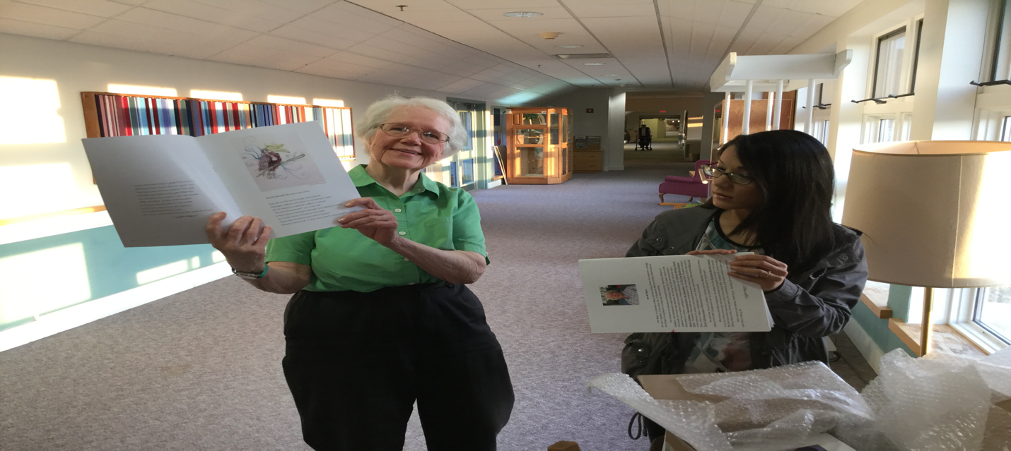
Ken, this photo was taken yesterday, March 8, when my books finally arrived. It was quite a journey! I am autographing a copy for you and each child who did illustrations. Watch for them next week.

March 9, 2016 Ken’s reply.

Yeah! What a happy day. Congratulations Ann! I will look forward to receiving the books and showing them to everyone. You know the kids/artists will be thrilled to get them.

March 9, 2016 on the Facebook page for A-Team for Wildlife

A-Team for Wildlife's first ebook, featuring art by members of the International A-Team, has now officially become our first published hardcopy book! 500 copies of "Endangered Animals of Nepal" are being distributed to children in need in Nepal. Congratulations to poetry author, Ann Mayer, and the young artists who contributed their beautiful art! Making a difference in the world once again.

. Nepal – Areas where my book was distributed.
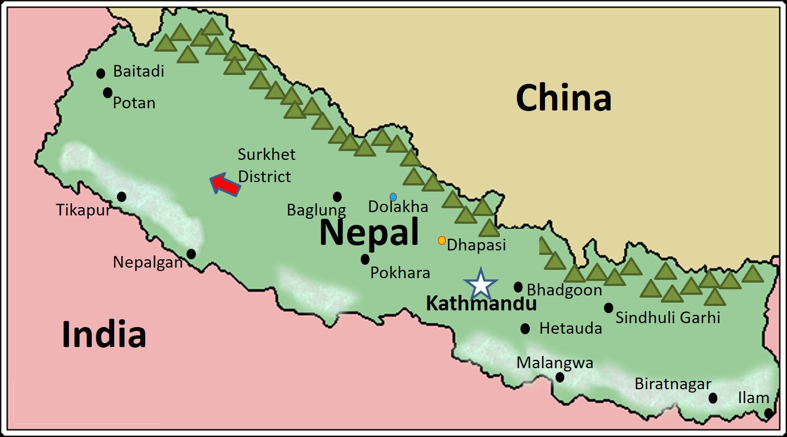

Surkhet District, one of Nepal’s 75 districts. Located in Bheri Zone. Site of Kopila Valley School operated by BlinkNow Foundation, founded by Maggie Doyne (2015 CNN Hero of the Year)

Dhapasi, Village where the Nepal Orphans’ Home is located

Dolakha, the area where ETC is helping with education and building schools.

Kathmandu, the capital of Nepal. The Red Panda Network is distributing my poetry book in parts of Kathmandu, as well as Terai and the mountain regions.

Terai is the lowland area near the border with India. Climate is tropical; weather hot and humid.

Mountain regions are middle mountain, high mountain and Himalayas. The Himalayas have the tallest peaks and are famous for Mount Everest which has the highest elevation above sea level of any mountain in the world.

